Underdog Academy
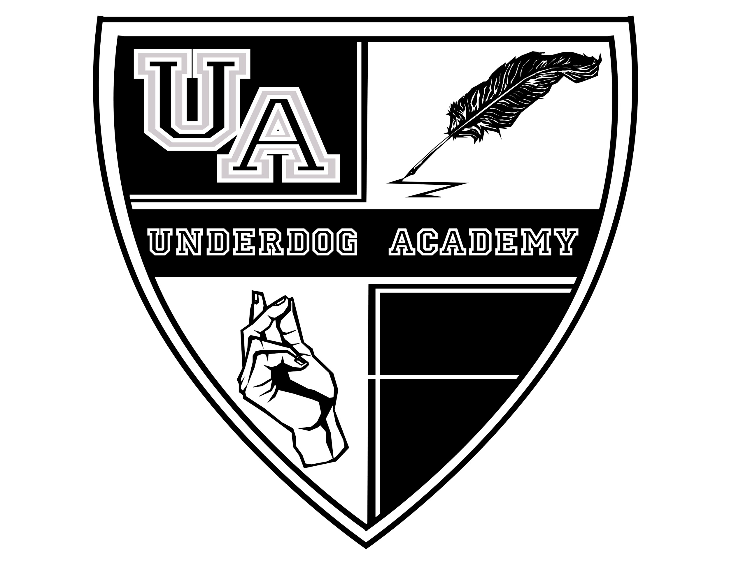
Hospitality Rider

- Water (2x performer)
- 1 Hand Towel per performer
- Bluetooth Speaker
- Refreshments (fruit, cheese, etc.)
- Hot Tea / Honey & Lemon

