Underdog Academy
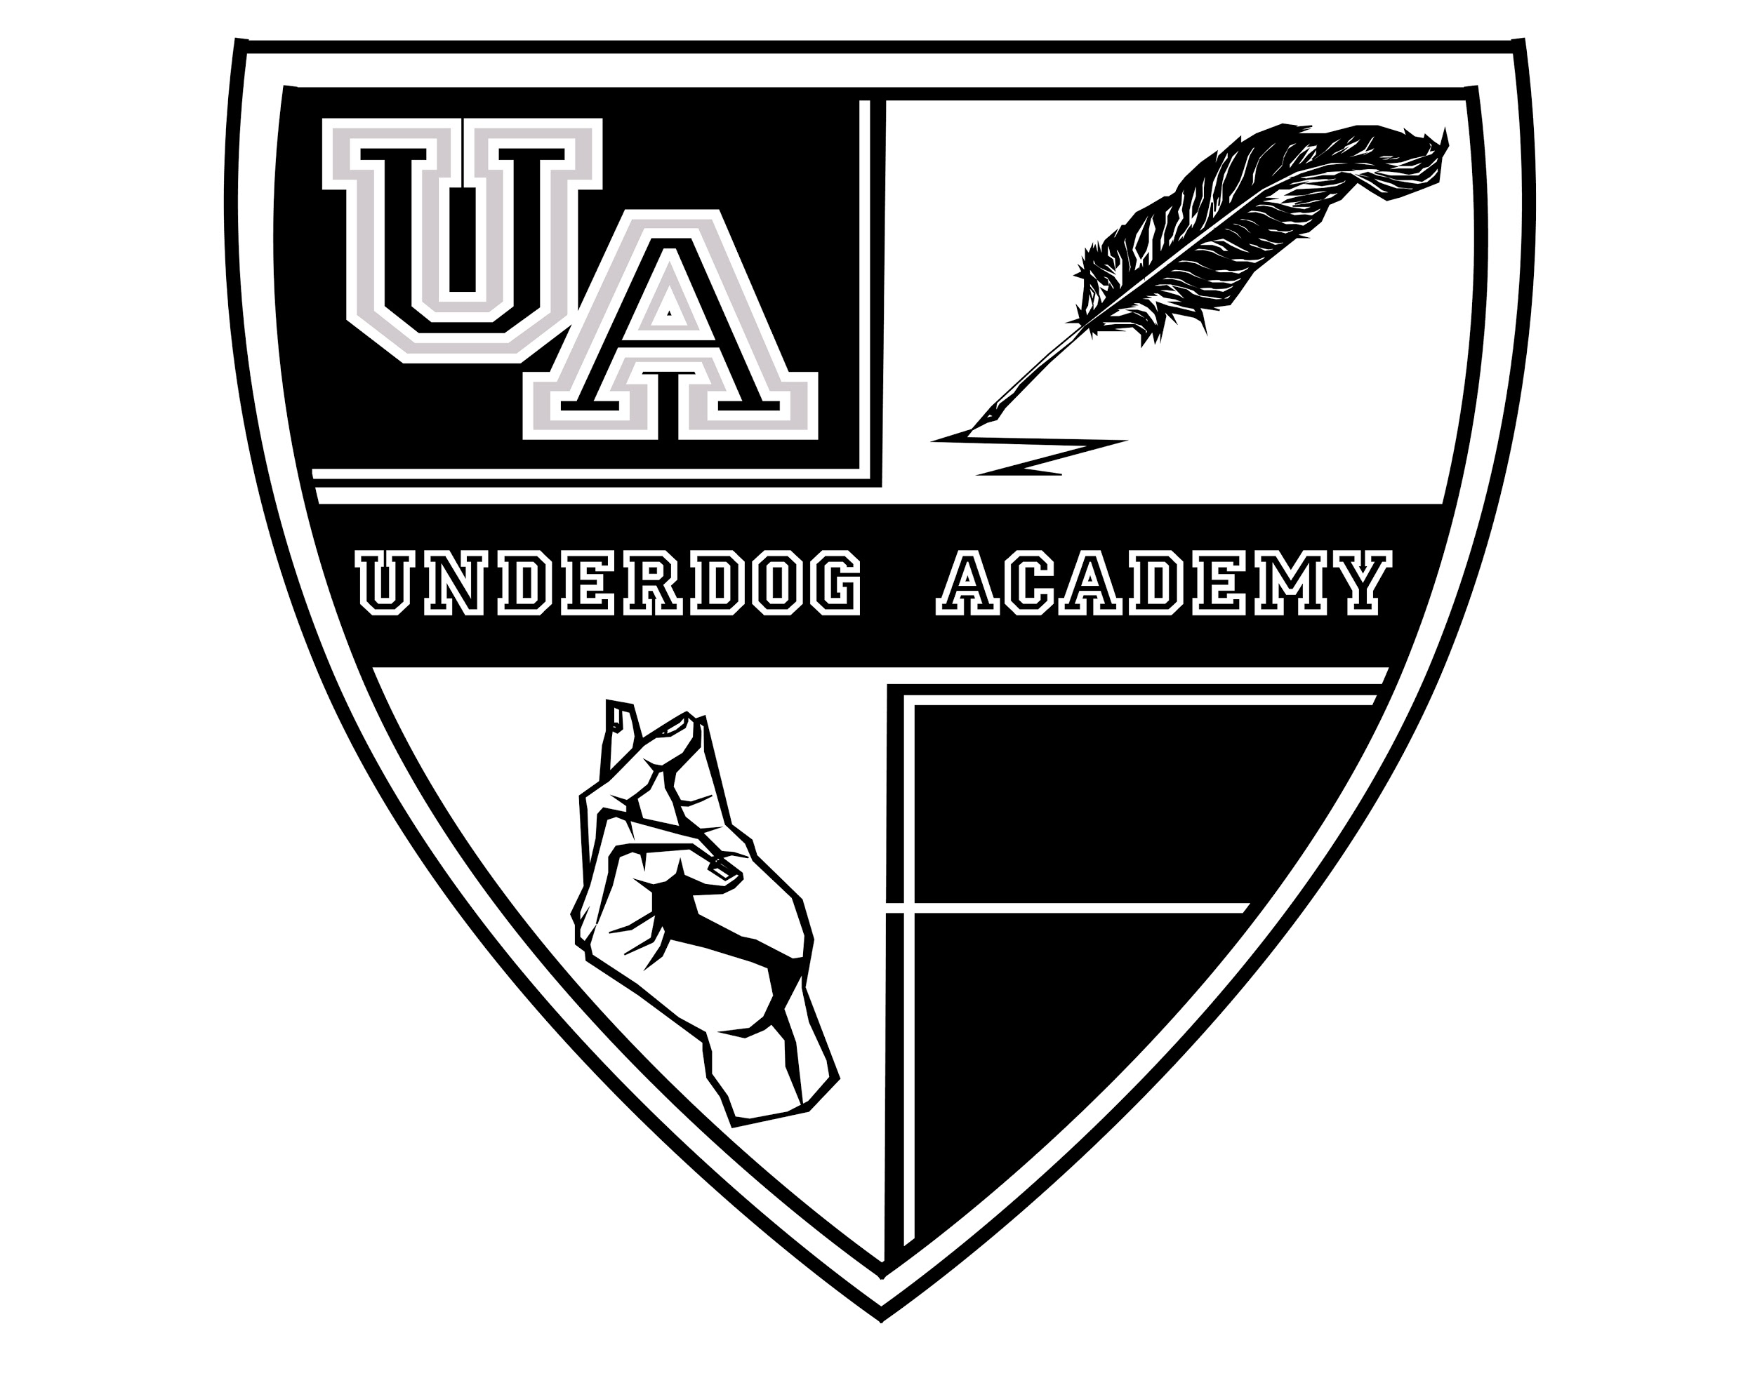
Technical Rider
Audio

2 Microphones ( Wireless or wired is fine)
2 Microphone Stands
Speakers or sound system adequate to performance space
Mixer that allows DJ hook-up

